**3. UI Mockups and Storyboards (high level only) V2**

**3.1. Customer Registration**

User gets redirected to registration page on clicking sign-up from Home page. Registration page will have the same header and footer of the Landing/Home page. This page captures all data for registration. Registration will be based on the First and Last name, CIN, Phone number, Password, Secret Question, and Secret Answer (for security matters). In addition date of birth, Postal Address, Profile Picture and user name is captured.

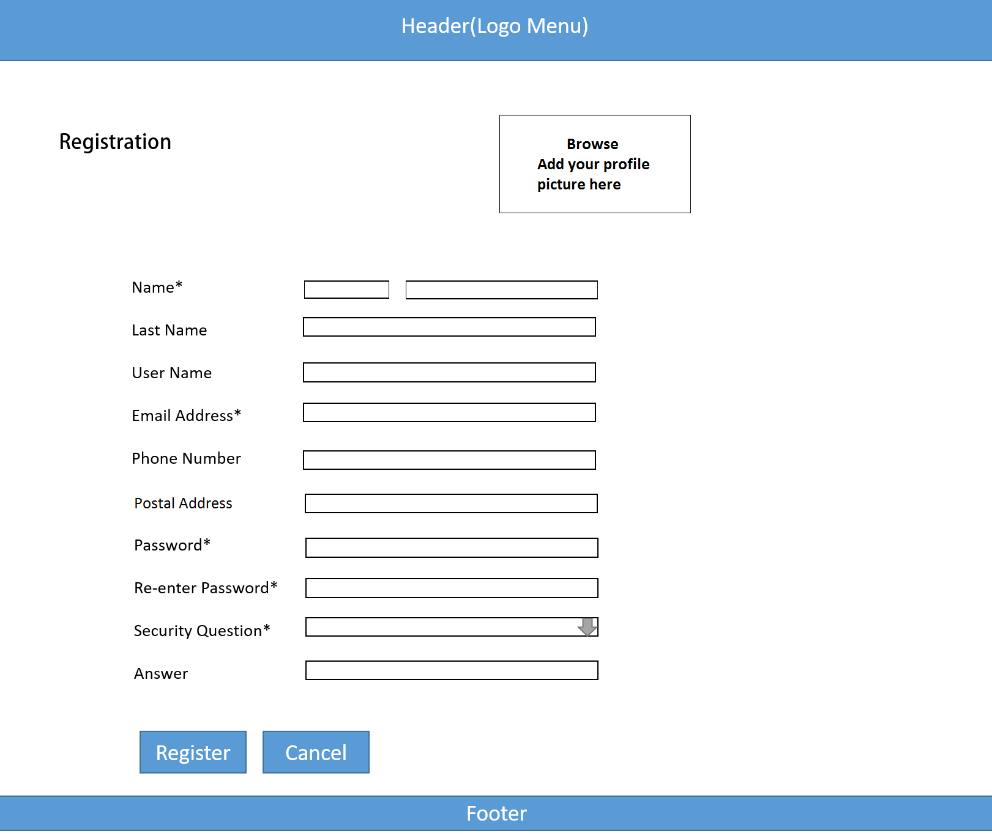

Image: 3.0

**3. UI Mockups and Storyboards (high level only)**

**3.1. Customer Registration**

User gets redirected to registration page on clicking sign-up from Home page. Registration page will have the same header and footer of the Landing/Home page. This page captures all data for registration. Registration will be based on the First and Last name, CIN (system generated), Phone number, Password, Secret Question, and Secret Answer (for security matters). In addition date of birth and user name is captured.

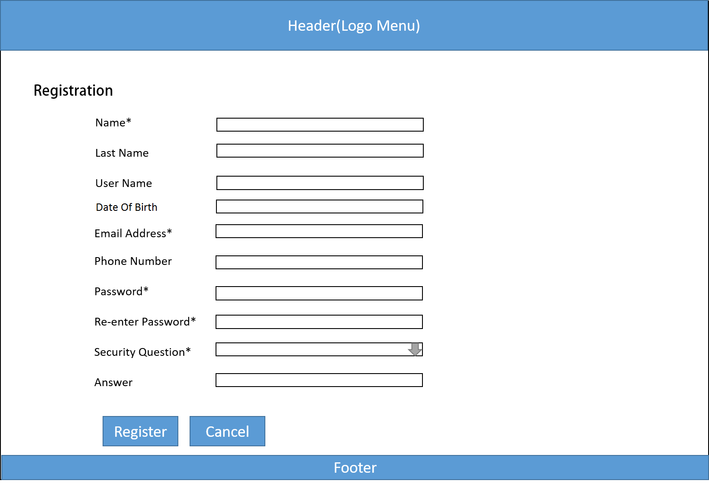

Image: 3.0